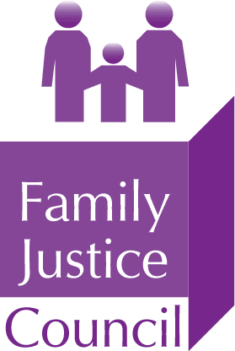

* Invitation to the judiciary and legal, medical and allied professions *

Family Justice Council webinar (MS Teams):

Experts and the Family Justice System: Widening the Pool

Wednesday 13 October 2021
5.30pm to 7.30pm

Due to the over-subscription of the previous webinar in March 2021, the Experts Sub-Committee of the Family Justice Council invites anyone who missed out on that event to register their interest in this webinar: Experts and the Family Justice System: Widening the Pool. The event aims to explain and promote expert witness work in the family courts and is open to the judiciary and the legal, medical and allied professions. It is particularly aimed at health professionals who are either new to expert reporting or wish to become experts, and to legal professionals who are up to 10 years PQE.

One of the key findings of the President of the Family Division’s Working Group on Medical Experts in the Family Courts was the need for more medical expert witnesses, in relation to the cause of injuries, but also experts from the allied professions including child and family psychiatrists and psychologists. The main shortages identified were paediatricians, radiologists and neuroradiologists, neurosurgeons, ophthalmologists, haematologists, neonatologists and geneticists. More information can be found at: Working-Group-on-Medical-Experts-Final-Report-v.7.pdf (judiciary.uk)

This webinar sets out, therefore, to encourage more expert witnesses into the family courts. It will explain the role of the expert witness, the court process and report writing. Speakers will share best practice and personal experiences. It also hopes to promote greater awareness within the legal professions by looking at their best practice in relation to expert witnesses.

The full programme is available here.

The role of the expert in the family court can be greatly rewarding and we believe that the protection of the vulnerable child is the responsibility of all. Those conducting the work have identified many positives from doing so, both in terms of their clinical practice but also public service. Ultimately, a strengthened expert witness workforce, together with the legal and other professions, will deliver the best outcomes for children, young people and families.
The primary role of the Family Justice Council is to promote an interdisciplinary approach to family justice and monitor how effectively the system operates in England and Wales. More information can be found at: https://www.judiciary.gov.uk/related-offices-and-bodies/advisory-bodies/fjc/

REGISTRATION:
To register your interest in this event, please notify the FJC Secretariat at fjc@justice.gsi.gov.uk by 1pm on Friday 1 October 2021. Please let us also know your profession and organisation. We will aim to confirm a place and send joining instructions by Tuesday 5 October 2021.
There is no charge for attending this event.

Twitter - #FJCevents

Family Justice Council webinar:

Experts and the Family Justice System: Widening the Pool

Wednesday 13 October 2021, 5.30pm to 7.30pm on MS Teams

Chaired by The Honourable Mr Justice Williams
High Court Judge of the Family Division

PROGRAMME

17:30 Welcome and introduction: Converting aspiration to reality
Mr Justice David Williams, High Court Judge of the Family Division

17:50 Preparing an Expert Report for the Family Court and Lessons Learnt
Dr Adam Oates, Consultant Paediatric/Neuro Radiologist

18:10 The contribution of the psychologist expert witnesses to the family courts
Dr Jaime Craig, Consultant Clinical Psychologist

18:30 Tips and Traps for Experts:

Experts in the family court - the basics
Maud Davis, Solicitor

When expert evidence goes wrong – lessons from the case law
Sharon Segal, Barrister

Experts and the family justice system – a paediatrician’s perspective
Dr Fiona Straw, Consultant Community Paediatrician

19:00 Q&A (via Teams chat bar)

19:30 Close

