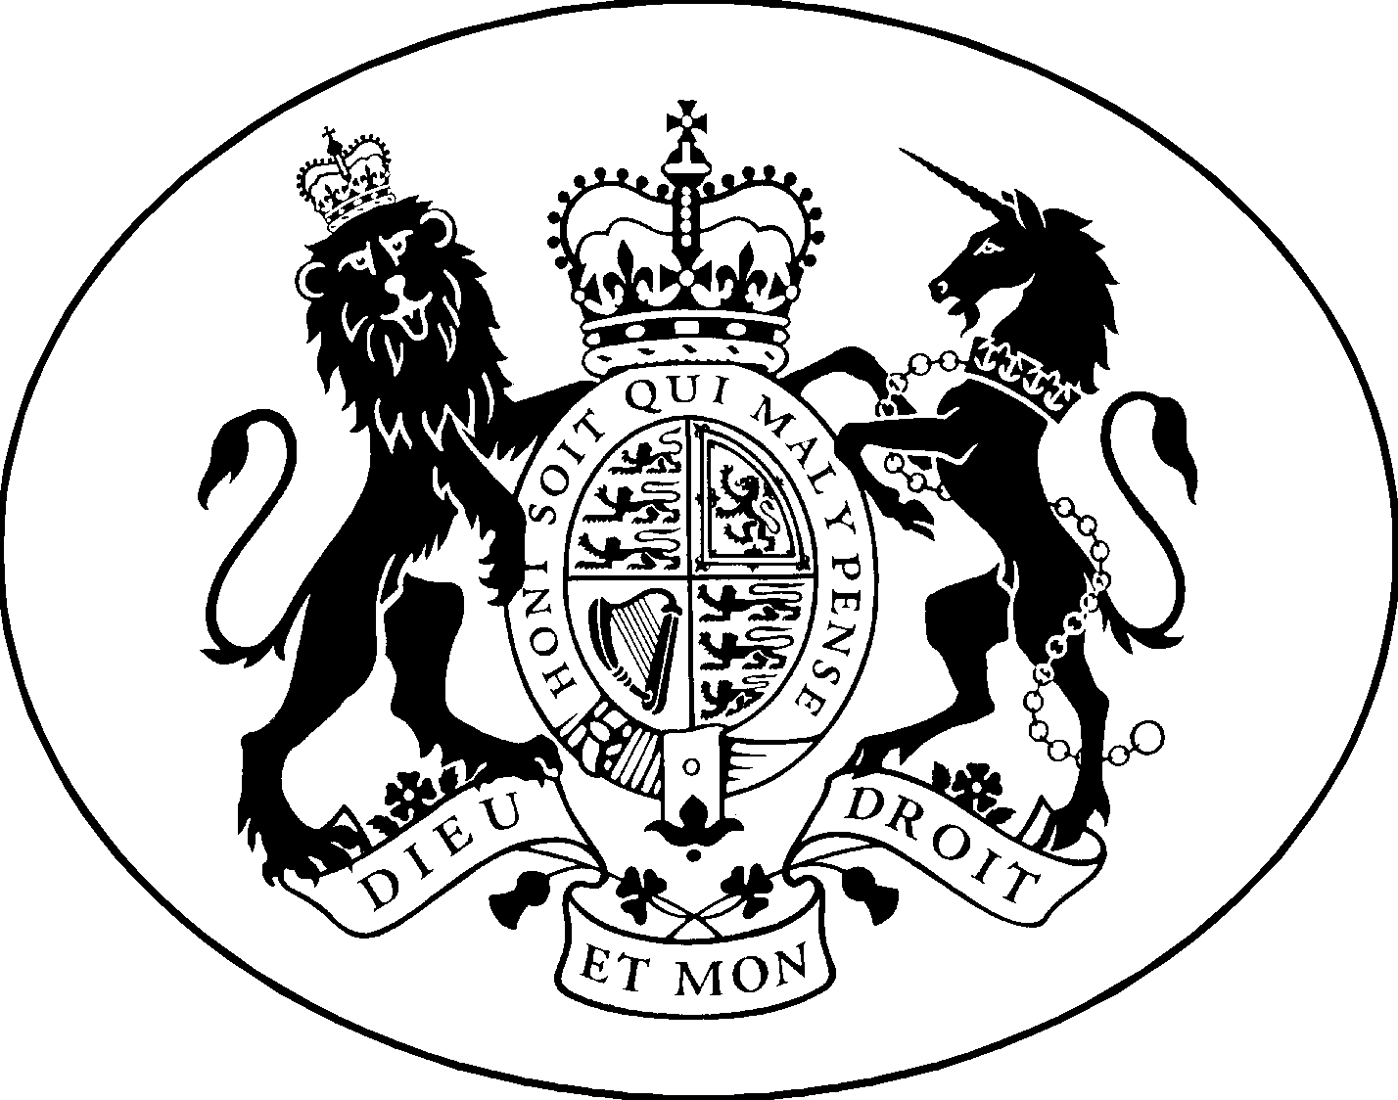

EMPLOYMENT TRIBUNALS

(England and Wales)

CASE MANAGEMENT ORDER
OF THE PRESIDENT

Case Nos 2405002/2017 & others

In the matter of claims brought against Chief Constable of Lancashire Constabulary and others relating to unlawful deduction from wages claims, based upon improved maternity pay provisions in the 2017 Pay and Conditions of Service

BETWEEN:

Miss K Armstrong and others CLAIMANTS

AND

1. Chief Constable of Lancashire Constabulary & others RESPONDENTS

Claims against Chief Constables having been registered in different regions of the Employment Tribunals in England and Wales raising the same or similar issues

AND the President having been advised on 12 December 2018 that claims against Lancashire & Cheshire Police were resolved between the parties and that the claims against Greater Manchester Police proceeded to a hearing on 10 April 2018.

AND having also been advised of the judgment in case no. 2405015/2017 and others Ms C Elliott & others v Chief Constable of Greater Manchester Police decided by the Employment Tribunal sitting at Manchester on 10 April 2018.

IT IS ORDERED THAT

- The stay on all claims in England & Wales raising the same or similar issues is lifted with immediate effect.

- Any party or representative wishing to make representations for the further conduct of any such claims should do so upon application to the relevant Regional Employment Judge.

- A copy of this Case Management Order be sent to ACAS and to all known interested parties, and be published on the Judiciary website at :
https://www.judiciary.gov.uk/publications/directions-employment-tribunals-england-wales

SIGNED:
Judge Brian Doyle
President

DATED: 19 December 2018

