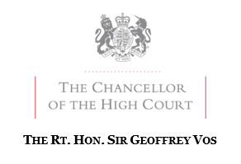

Practitioners have expressed concern regarding the effect of the appointment of an administrator purportedly made by filing a notice of appointment via the court’s electronic filing system, outside the court’s usual counter-opening hours.
It is anticipated that these issues will be addressed by amendment to the Insolvency (England and Wales) Rules 2016. Until then, court clerks will be directed to process filings in the manner set out in this note. Note that the amendments relate to Notices of Appointment only and not Notices of Intention to Appoint.

Appointment of administrators by a company or its directors under paragraph 22 of Schedule B1 to the Insolvency Act 1986
Notices of appointment of an administrator by a company or its directors under paragraph 22 which are CE-filed when the court is closed will be referred by the court clerks at the first possible opportunity to a specified High Court Judge. The Judge will determine the validity and, if appropriate, the time at which the appointment takes effect. The Judge’s determination will be made on paper or following a short hearing, for which he may request written or oral submissions.

Appointment of administrators by a qualifying floating charge holder under paragraph 14 of Schedule B1 to the Insolvency Act 1986
Rule 3.20 of the Insolvency (England and Wales) Rules 2016 provides that when the court is closed the holder of a qualifying floating charge may file a notice of appointment of an administrator pursuant to paragraph 14 of Schedule B1 with the court by fax to a designated telephone number or by email to a designated email address. If such a notice is not filed in accordance with Rule 3.20, but instead is CE-filed when the court is closed, it will be referred at the first possible opportunity to a specified High Court Judge who will determine the validity and, if appropriate, the time at which the appointment takes effect. The Judge’s determination will be made on paper or following a short hearing, for which he may request written or oral submissions.

January 2020

