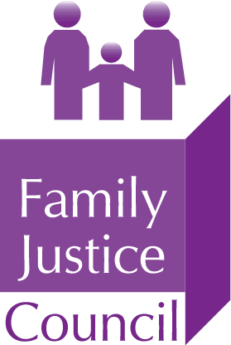

Twitter - #FJCevents

Family Justice Council webinar:

Experts and the Family Justice System: Widening the Pool

Wednesday 13 October 2021, 5.30pm to 7.30pm on MS Teams

Chaired by The Honourable Mr Justice Williams
High Court Judge of the Family Division

PROGRAMME

17:30 Welcome and introduction: Converting aspiration to reality
Mr Justice David Williams, High Court Judge of the Family Division

17:50 Preparing an Expert Report for the Family Court and Lessons Learnt
Dr Adam Oates, Consultant Paediatric/Neuro Radiologist

18:10 The contribution of the psychologist expert witnesses to the family courts
Dr Jaime Craig, Consultant Clinical Psychologist

18:30 Tips and Traps for Experts:

Experts in the family court - the basics
Maud Davis, Solicitor

When expert evidence goes wrong – lessons from the case law
Sharon Segal, Barrister

Experts and the family justice system – a paediatrician’s perspective
Dr Fiona Straw, Consultant Community Paediatrician

19:00 Q&A (via Teams chat bar)

19:30 Close

