# THE ELECTRONIC COURT OF PROTECTION BILL (COP-E): GUIDANCE NOTES

**COP-E Bill Pilot Update**

Following successful completion of the pilot, as from 23 March 2023 the use of COP-E bills has been made permanent but remains voluntary. The COP-E bill may be updated periodically, and therefore please always refer to [Electronic bills in Court of Protection cases - Senior Courts Costs Office](https://www.judiciary.uk/guidance-and-resources/electronic-bills-in-court-of-protection-cases-pilot-in-the-senior-courts-costs-office/) to ensure you are using the correct version.

Version control:

|  |  |  |
| --- | --- | --- |
| Version number | Date in use | Comments |
| v1.0 | 1.11.2022  Do not use after 06.11.2023 | Pilot version |
| v2.0  (v2.1 blank template) | July 2023  August 2023 | Updated following the pilot  Minor amendment to blank template only. |

**Changes to COP-E Bill (Version 2)**

The version of the bill can be seen on worksheet 1. Front Sheet in cell A1

|  |  |
| --- | --- |
| **Worksheet** | **Changes** |
| 1. Front Sheet | * A Box has been added to insert the protected party’s name. * Changed Solicitor’s Name to Solicitor’s Firm * DX Address added |
| 2. Background | * No change |
| 3. Chronology | * Updated to have a statement of parties for those contested cases or multiple party cases |
| 4. Fee Earners & Rates | * Z codes removed – Costs Officers may add additional codes for fee earners on a case-by- case basis |
| 5. Parts | * No change |
| 6. Bill Detail | * The one yellow cell has been removed from column O * Activities codes for letters have been changed to include emails and have the word ‘Out’ added |
| 7. Main Summary | * No change |
| 8. Activity Summary | * Pivot table updated to show work done by grade of fee earner * Shows change of activity code name for codes C04, C05 and C06 |
| 9. Comms Summary | * Shows change of activity code name for codes C04, C05 and C06 |
| 10. FE Grade Summary | * No change |
| 11. Certification | * Heading added to first part to show ‘Pre-Assessment Certificate’ |
| 12. Cert Summary | * No change |
| 13. Final Certificate | * No change |
| 14. Bill detail (Print) | * No change |
| 15. Ref-Activities | * Codes C04, C05 and C06 amended to include emails and had the word ‘out’ added |
| 16. Ref-Expenses | * No change |
| 17. Ref-Findings | * No change |

**The Introduction of Electronic Bills**

In October and November 2017 the Civil Procedure Rules were amended to require (for all work undertaken after 6 April 2018) that bills of costs between the parties to most CPR Part 7 multitrack claims be in electronic spreadsheet format. The published model for such bills is Precedent S, annexed to Practice Direction 47.

Precedent S is a self-calculating spreadsheet. It produces automatic summaries for ease of reference (for example, comparing incurred costs to approved budgeted costs) and it allows an assessing judge or costs officer to isolate particular entries or groups of entries for fast review and adjustment. The bill will recalculate itself automatically as changes are made. Ultimately, electronic bills like Precedent S should be capable of production primarily from electronic time records rather than through a labour-intensive and expensive manual process.

In early 2020 the Senior Costs Judge invited representatives of the SCCO and costs professionals specialising in Court of Protection to form a working group, with a view to designing a form of electronic bill suitable for use in the Court of Protection.

“COP-E” is the result. It was designed for use in a voluntary pilot by professional deputies and their legal representatives. Legal aid bills, bills with a legal aid element, and bills for work done in relation to applications to the Criminal Injuries Compensation Authority are however excluded from the pilot.

The pilot came to an end on 28 April 2023 but due to it’s early success the Senior Costs Judge issued a practice note on 23 March 2023 declaring the pilot a success and that the COP-E bill be made permanently available for Court of Protection bills of costs.

Accompanying this note are three spreadsheet versions of “COP-E”. One contains no information and is intended to be completed by the user. The second, “example data” version is intended to show what a completed “COP-E” will look like and how it will work on assessment. The third shows what “COP-E” might look like following a provisional assessment.

Also accompanying this note is an example PDF version of “COP-E”, suitable for printing and service in hard copy. The content and purpose of the PDF version is explained below.

**The Content of “COP-E”**

“COP-E” comprises a series of “worksheets” (spreadsheet pages) containing, apart from familiar items such as the cover sheet and certificates, summaries designed to facilitate assessment, supported by full details of the costs claimed.

Each worksheet is divided into “cells”, into which the figures making up the bill are entered. Spreadsheet cells can interact with each other to perform complex calculations: built-in mathematical formulae and “pivot tables” (summaries automatically derived from the detailed data entered into the spreadsheet) ensure that changes made to the detail of the bill feed through to the summaries, disposing of the need for manual recalculation of the bill on assessment.

Spreadsheets place more emphasis on function, and less on presentation and printing, than do word processing applications. “COP-E” has been designed to cope with large bills of costs and is designed for electronic transmission and management on screen rather than on paper.

Spreadsheets are however designed to present very large amounts of information in any number of ways, in as much or as little detail as is needed. Once familiar with the bill’s structure and with certain spreadsheet management techniques, users can navigate through the bill, cut worksheets down to size, isolate required information, make unwanted information disappear and have the bill automatically perform such calculations as may be required for the purposes of assessment.

The worksheet containing the full bill detail may be impracticable to print. The summaries can be printed. A reduced version of the detail worksheet is included in “COP-E” to allow as complete a version as possible of the bill to be converted to PDF format (see below under the heading “Worksheet 14: Bill Detail (Print Version)”).

The court will require only the spreadsheet version to be uploaded to CE-File, but where service on a third party is required both the spreadsheet version and a printed copy of the reduced PDF version must be served.

**Work Categories**

To perform its functions, “COP-E” requires every entry in the bill to be assigned at least one “code” either an Activity Code in column F or an Expense Code in column H (letters and numbers identifying the type of work, the fee earner undertaking it etc). Codes allow the bill to process information and perform its calculations allowing an assessing costs officer to use the bill’s built-in filters quickly to find and review the type of work or expense which they wish to consider.

“COP-E” incorporates 12 pre-set types of work activity and 13 types of expenses, each with its own code. They are listed at “Reference” worksheets 15 and 16 and are reproduced at Appendices A and B to this note. Worksheet 17 is a blank reference table of findings and is only to be used by the assessing costs officer.

Although “COP-E” generally uses the term “disbursements”, for coding purposes the word “expenses” is used, for maximum compatibility with time recording software. Items should only be included in “other disbursements” if they do not fall within any of the other specified types of expense.

**Colour Coding**

Most of the cells in “COP-E” have a white background. Cells containing formulae which are not meant to be overwritten have a purple background. Cells coloured blue are intended for use by the costs officer on assessment.

The figures in the bill may change up to three times: on provisional assessment, on reconsideration on paper and in any hearing before a Costs Judge. On initial changes to the bill detail, cells will automatically be highlighted in yellow for ease of reference. It is not possible to build in different cell highlighting for further changes at the post-provisional stages, on reconsideration or hearing. Users should still be able to spot quickly the changes made at the post-provisional stages because the costs officer or judge will highlight their findings on red-background cells and will have saved the re-assessed bill under a new name and the summaries automatically produced by each version can be quickly compared and changes noted.

**Please note:** On initial filing no cells in the bill should be coloured yellow as this would indicate that a formula has been overwritten and may result in the filing being rejected.

**File Naming**

Electronic Court of Protection bills submitted to the SCCO should be named by reference to the year of management/authority type and the client, for example:

SMITH – 2018-2019 – BILL

SMITH – 2019-2020 – BILL

SMITH – PROPERTY SALE – BILL

Examples of “authority type” can be found in the notes for Worksheet 13, below.

**The structure of “COP-E”**

“COP-E” comprises 17 worksheets (pages), the last three of which contain the reference data for activities, expenses, and any findings added by the costs officer.

The following is a short summary of the content of the 14 “active” worksheets shown in the “example data” version of “COP-E”.

**Worksheet 1: Front Sheet and Worksheet 2: Background**

These are the bill’s cover sheet and summary of the relevant background. Some details such as the case number will feed through to the Final Costs Certificate (at worksheet 13) and to enable this function to work please ensure details are entered in the relevant cells. The SCCO will add its reference to worksheet 1 on submission of the first bill on a given case. After that it should be included when drafting the bill.

The person drafting the bill can enter in worksheet 2 a general overview, including but not limited to:

* Why the Protected Party lacks capacity, e.g. dementia diagnosis, injury at birth, road traffic accident.
* The Protected Party’s current living and care situation, e.g. living at home, care team employed etc.
* Litigation position (if relevant) including details of the settlement and any periodical payments.
* Main events in the year, or details of application/order if not general management.
* Any problems/issues that have arisen.
* Any applications made to the court and resulting orders.
* Who the main fee earner is dealing with the matter..
* Any other appropriate information for the costs officer.

In the box provided, worksheet 2 should show the OPG105 overall estimated costs for the bill period if the costs in the bill relate to general management or, where it is for the first general management year, please state this is the case. Where costs exceed the OPG105 estimate for the relevant period by 20% or more, an explanation must be included in the background information.

As the “example data” version of “COP-E” shows, in non-welfare cases the client’s total asset figure, if known, should be shown in the expandable box headed “Non-Welfare cases - value and breakdown of P's assets (if known)”, along with a breakdown to show, for example, the split between properties, bank accounts, investments and other assets. If the value of the assets is not known, a short note as to the reason would be helpful.

The “Assessor’s Comments” box is only to be completed by the assessing officer and will expand automatically to accommodate the assessing officer’s observations.

**Worksheet 3: Chronology**

For bills where there have been multiple hearings and orders, for example in a disputed deputyship application or a contested Statutory Will bill, a statement of parties and timeline needs to be given. The role of the party, e.g. ‘Applicant’, ‘First Respondent’ should be stated under the ‘Party’ heading and then the name of that party and who is representing them (if applicable) under the ‘Name & Representative’ heading. The timeline information can then be set out by first stating the date of the event followed by the details of what happened or the terms of the order made. There should be enough space for even the largest of bills to accommodate all entries. Where there is a profit cost or disbursement/expense, such as Counsel’s fees, attached to the event these will still need to be set out separately in Worksheet 6 (Bill Detail) as this is from where the costs are calculated and feed through to the main summary. Worksheet 3 is not expected to be completed for all bills such as for general management or uncontested applications.

**Worksheet 4: Fee Earners and Rates**

Worksheet 4 provides details of each fee earner and of their hourly charging rates for given periods. This is the first of two worksheets (4 and 6) from which changes made by the assessing costs officer, for example to a solicitor’s hourly rate, will feed through to the relevant parts of the bill, automatically changing the summaries and the bill total. Overwriting the summaries on other pages may erase the bill’s built-in formulae and stop it functioning as it should.

Every fee earner whose work is included in the bill must be individually identified, rather than, for example, identified only by grade (*AKC v Barking, Havering and Redbridge University Hospitals NHS Trust* [2022] EWCA Civ 630. Rows can be added to worksheet 4 to accommodate any number of fee earners.

All columns have been abbreviated to show FE meaning Fee Earner. The fee earner’s initials should be entered in column A and can have a number added if they feature more than once at different rates, e.g. ABC1, ABC2. Column B must give the name of the fee earner and their status should be entered at column C, i.e. Partner, Associate, Solicitor etc. Their grade, at column D, should mirror those grades as set out in the guideline hourly rates, i.e. A, B, C, D, and the Further Relevant Information at column E allows for more detail, e.g. qualification period.

Alongside the column showing the hourly rate claimed for each fee earner (column F) is a column showing the hourly rate allowed (column G). When the bill is drafted, the claimed figure entered in column F will automatically be duplicated, using a built-in formula, in column G. The assessing officer can change the amount allowed simply by entering a new figure in the “allowed” column G (overwriting the formula). The bill will recalculate accordingly.

The Costs Officer on assessment may add additional rows for further fee earners to account for delegation and other rates as appropriate. An example is where a costs officer allowing time at Grade C for work claimed at Grade A can create a “virtual” Grade C fee earner at a suitable Grade C rate and substitute the Grade C initials for the Grade A where appropriate.

~~Just below the entries in columns A and C (fee earner code and status) are three additional entries which the assessing costs officer will, if required, complete. They are: Z1 (Blended Rate); Z2 (Payroll Rate); and Z3 (Non-Fee Earner Rate). The assessing costs officer will set these rates only if they take the view that particular work should have been done at those rates. In that event they can substitute Z1, Z2 or Z3 for other fee earner codes in the bill detail. Page 3 incorporates comment boxes for the assessing officer to add observations on hourly rates.~~

**Worksheet 5: Parts**

This worksheet allows the bill to perform calculations which in paper bills can only be performed by physical division of the bill into parts. (The bill will still effectively be divided into parts, but in a more user-friendly way). Where for example different VAT rates apply during periods covered by the bill, an identification code (“Part ID”) will be created for each relevant period and entered in this worksheet. The person drawing up the bill will apply the appropriate code to each item of cost. The bill will then automatically calculate the correct VAT rate on each item and send that to the summaries. If individual items are adjusted on assessment, the VAT will be recalculated automatically. (The need to make a manual adjustment where an individual entry does not carry the standard rate of VAT is addressed below).

If there is no need to distinguish between different stages, it will still be necessary to enter a part code against each item of work so that VAT will be calculated automatically, but a single part code can simply be pasted into every row on worksheet 6 (bill detail) rather than entered multiple times.



**Worksheet 6: The Bill Detail**

This is the second of the two worksheets (4 and 6) on which the assessing costs officer may make changes to the figures. It is where all individual and detailed entries appear. From these entries the bill derives its summaries and calculates the total of the bill as claimed and as allowed. Worksheet 6 is where most of the work is likely to be done on assessment.

**Please note:** Only those cells in white should be completed on drafting the bill, the blue and purple cells contain formulae which must not be overwritten. There is a helpful guide as to what information should be entered in each column of worksheet 6, which can be found at appendix D.

As with worksheet 4, when the bill is drafted columns K and M (time allowed and fee earner allowed) will automatically duplicate the claimed figures entered in columns J and L (time claimed and fee earner claimed). The claimed time at column J can be entered in any number of minutes (though the six-minute unit remains the accepted standard). The bill will round all individual entries to two decimal places but will calculate totals by reference to the actual number of minutes claimed or allowed.

The assessing costs officer will make any changes to column K (time allowed) and column M (fee earner allowed) by overwriting the figure duplicated from columns J and L. “Cut and paste” can be used to quickly change multiple entries. The bill will automatically change the summaries and totals as these changes are made.

The mass of detail at worksheet 6 can look intimidating at first sight but it can be reduced to show only what the assessing costs officer needs to see with a few mouse clicks. Unwanted columns can be “hidden” to allow the costs officer to focus on those of most use.

Filtering will isolate the entries in each column that the costs officer wishes to see. So, for example, if the costs officer takes the view that a Grade C fee earner should have undertaken some of the work done by a Grade A fee earner, the costs officer can use filters to show only the work done by the Grade A Fee Earner, filter further to identify only the work that should have been done at Grade C and in column M enter the Grade C fee earner code for all those entries at once.

At the foot of key columns such as J and K (claimed and allowed time) and U and V (claimed and allowed disbursements) is a subtotal of all entries in that column. Subtotals automatically adjust when the person reviewing or assessing the bill uses filters to view particular entries. So, for example, if filters are used so that worksheet 6 shows only communications with a particular person, the subtotal at the foot of column J will change to show the total time claimed for those communications. Subtotals also change automatically when changes are made to the figures. This should assist cost officers, in particular in making broad-brush adjustments, and provide parties with a quick overview of reductions made to particular categories of work.

Broad-brush reduction approaches may be indicated by the Costs Officer in various ways by either reducing the time or profits costs allowed for a single item or by inserting a new line of entry with a total allowance.

Examples are where the Costs Officer applies the decision in *Trudy Samler* and wishes to reduce the level of communication with the Protected Party:

* *Single item reduction –* all work has been claimed by the same fee earner and they have claimed 300 letters to the Protected Party which the Costs Officer sees as too high – the Costs Officer can make a general reduction to the time claimed and enter their reason in the Findings column.
* *New line item – allowing a total figure thereby reducing the overall claim for contact* – the Costs Officer wishes to reduce the overall level of contact so they could insert a new line of entry above the first item that shows the Protected Party as the External Party Name in column E. The item number given in column A will be entered as the same as the line below, i.e. the first time the External Party Name shows the Protected Party is Item 1, the new line inserted will also be given the Item number 1 – this is so that they stay together and make it clear at the start what the deduction relates to. The Activity Code will be entered as C01 Personal Attendances. A brief description in column D will be given to show that this entry is to reflect a general reduction (or overall allowance) and a total allowed figure will be entered in the Profit Costs Allowed column. The costs officer will provide an explanation in the ‘Findings Text’ column and all other entries in relation to contact with the Protected Party would be reduced to zero with a note in the ‘Findings Text’ referring to the item number that has been inserted. The costs officer will make sure there is a Part ID to ensure that the VAT is calculated and will complete all relevant columns that feed through to the summaries.

Other than contact, there may be circumstances where the costs officer wants to allow an overall figure for work carried out:

* *New line item or items for activity code C09 Plan, prepare, draft, review* – where there is a collection of work done on the same issue the costs officer may wish to make a general allowance for the work carried out ,which was claimed as various items within the bill. In the same way as the previous example, the costs officer will insert a line above the first entry that relates to that area of work, e.g. OPG Report 102. If the work has been claimed by various fee earners the costs officer may insert multiple lines to reflect what they are allowing on assessment to each fee earner (either by name or grade of fee earner). The costs officer will complete all relevant cells within the row(s) and will reduce all other items that relate to this work to zero, as an overall allowance has already been given. The reason for the reduction will be made in the ‘Findings Text’ column and all other entries that were claimed will refer to the item number where the overall allowance has been given.

Column D Description of work **must** be completed for every entry.

Activities that show communication methods at column G includeuntimed letters/emails out and calls (6 minutes), enclosure letters (3 minutes), and timed letters/emails out and calls. The term “routine” is not used, to avoid confusion between untimed (6-minute) letters/emails and enclosure (3-minute) letters/emails.

Untimed letters/emails, untimed calls and enclosure letters must be entered collectively by fee earner under each category rather than listed individually, showing in column D (“Description of work”) the total number of items claimed. A bill might include for example 25 Letters/emails (2.5 hours), 19 calls (1.9 hours) and 25 enclosure letters (1.25 hours). Timed communications must be individually identified. The example data bill provides for how the grouping of these items should be set out by External Party Name and by Fee Earner, an excerpt of which can be found at Appendix E.

Against every entry in activity columns F and G, save for codes C08 (Hearing Attendances), C09 (Plan, Prepare, Draft, Review) and C12 (Bill of Costs) the bill **must** identify at column E the relevant external party. This is particularly important for feeding through to the summaries and for example to ensure that all travel and waiting time incurred in meetings with a client is shown in the bill’s summaries as such. Bills that do not comply with this requirement are at risk of being rejected.

The exception to the above paragraph is for “COP-E” bills in which profit costs do not exceed £3,000. These can still be submitted in “short form”, so that work can be grouped by activity and fee earner, rather than fully itemised. An example of a short form bill format can be found at Appendix F.

Any claim for checking the COP-E bill before filing should have Activity Code C12 applied and any claim for drafting the bill should have either Activity Code C12, if drafted in-house, with the total in the Profit Costs claimed column or Expense Code D02, if an external firm was used, and the total in the Disbs Claimed column.

VAT columns R, W and X may, in exceptional cases, need some attention when drawing the bill and on assessment.Column R, “VAT Rate”, applies the prevailing VAT rate (as entered in worksheet5, “Parts”) to all time and disbursements claimed and allowed. Column W shows the resulting “VAT claimed” figure and column X shows the resulting “VAT allowed” figure.

Although in the great majority of cases the calculation of VAT on each entry will be entirely automatic, a manual calculation may be required in the following instances:

* An item attracts VAT at a different rate to the prevailing rate for the relevant part. The person drafting the bill must manually alter the VAT rate at Column R (If the item does not attract VAT the rate to enter will be 0). The bill will then automatically recalculate the “VAT claimed” figure at column W and the “VAT allowed” figure at column X.
* A disbursement includes items that are both subject to VAT and not subject to VAT. The person drafting the bill cannot rely on automatic calculation and must instead manually enter the “VAT claimed” figure in column W. The “VAT allowed” figure at column X will automatically change to match. If the amount allowed for the item then changes on assessment the assessing officer will have to recalculate the “VAT allowed” figure at column X manually, as only the assessing officer will know the extent to which the change affects the vatable or non-vatable element of the disbursement

Columns Y and Z to the far right of worksheet 6 give details of findings made by the costs officer.

Users completing worksheet 6 should be aware of COP-E’s “code” functions and the potential problems arising if data is pasted from a time recording system directly into the bill. Please see Appendix C to these notes for details.

Limiting costs on COP-E: Where costs are to be limited, this needs to be made clear at the start of the Part of the bill to which the limitation relates. The top row for each part will need to have an Item No, Part ID and a note in the ‘Description of work’ at column D should be entered in bold and the cell highlighted in orange. The rest of the bill should be set out as normal without any further reference to the limitation. The Costs Officer will assess the bill in the usual way and if the assessment results in a higher profit costs figure than the limitation they will enter a minus figure of the difference in the Profit Costs Allowed column on the row(s) with the orange highlighted note. Where the assessment results with a lower figure than the limitation then the lower figure applies. An example of this can be found at Appendix G.

**Worksheet 7: Main Summary**

This is a simple summary of the amounts claimed and allowed, with a box for the assessing officer to enter any necessary directions, e.g. where a bill is provisionally assessed subject to service on interested parties or filing of documents.

It is important to remember that some of the bill’s summaries (those created by “pivot tables”) may not automatically change to reflect changes in the bill unless the “refresh” function is used. This can be done in several ways, including by selecting “Refresh All” on the “Data” tab in the menu ribbon at the top of each worksheet, or by right-clicking on any pivot table such as the Activity Summary on worksheet 8 (see below) and choosing “refresh”.

To demonstrate the way in which the bill recalculates summaries when individual items change, one can note the summary of the total bill at worksheet 7, then return to worksheet 4 (Fee Earners and Rates) and change any of the hourly rates. Using the spreadsheet’s “data/refresh” function (this may vary depending upon the type and design of spreadsheet) will automatically update the “allowed” totals at worksheet 7.

**Worksheet 8: Summary by Activity**

This worksheet provides an at-a-glance collective summary by fee earner grade as to the cost of communications**,** overall travel/waiting times, work done on documents and preparing/checking the bill

**Worksheet 9: Communications Summary**

This worksheet provides a breakdown of the total time spent on and cost of communications with each party within the bill of costs. This allows the costs officer to assess if the overall level of contact with each party was reasonable and proportionate.

**Worksheet 10: Summary by Grade of Fee Earner**

This worksheet provides a breakdown of all work claimed by each grade of fee earner and the time/costs allowed on assessment. The breakdown will assist the assessing officer to see at a glance what level of work the bill has been pitched at and will help the billing firm to know what grades have been allowed. The summary automatically calculates from the main bill detail and so will include any new fee earner rates that have been applied by the assessing officer.

**Worksheet 11: Certification**

This is where the bill certificates are completed. Following *Barking, Havering and Redbridge University Hospitals NHS Trust v AKC* [2021] EWHC 2607 (QB) a printed signature on this page will be acceptable, provided that it signed by an individual identified either as the deputy or as a solicitor acting for the deputy. The pre-assessment certificate should be completed prior to filing of the bill and the post assessment certificate is only to be completed when applying for the Final Costs Certificate.

**Worksheet 12: Certificate Summary**

The certificate summary is designed to show what has been allowed on provisional assessment against what was originally claimed in the bill. Most details are automatically updated as a result of input into the other worksheets. Where a costs officer has given directions in worksheet 7 “Main Summary” you must state at row 17 whether the directions have been complied with. If for any reason directions have not been fully complied with, this should be explained in the answer box or if necessary, a separate letter. Where the direction is in relation to service of the bill on interested parties, the date of service must be completed at row 19. For COP-E Bills this summary no longer needs to be filed separately when requesting the Final Costs Certificate.

**Worksheet 13: Final Costs Certificate**

This is the final order as to costs and is only valid where it carries the seal of the court. All entries highlighted are automatically updated from input into earlier worksheets.

When the figures in the Final Cost Certificate are accepted, the blank areas need to be completed at rows 16 and 18. The information to be entered will be dependent on the type of bill it relates to. In every case the solicitor must date the certificate at column E before submitting to the court (SCCO).

Where the bill relates to “General Management” the date of the order appointing the deputy/deputies should be given at row 16 and/or the date of the General Direction of the Court of Protection (i.e. ‘19 November 1982’). At row 18, details of the general management period should be given, for example ‘Upon the Deputy filing a completed bill of costs in respect of the general management for the period 10.01.2020 to 09.01.2021’. An example can be found at Appendix H

Where the bill relates to a specific application, the date of the order giving authority to have costs assessed in respect of those proceedings should be entered at row 16.  At row 18, further details of the authority should be given including details of the party to whom the bill is on behalf of, for example, ‘Upon the Second Respondent filing a completed bill of costs in respect of a Statutory Will application’. Example can be found at Appendix I

Where the bill relates to a mix of both scenarios, for example appointment of deputy and first year of general management, the solicitor will need to refer to both the specific order and the dates covered by the general management period.

There are many different types of authority and the following is an example but not exhaustive list of the most common types of authority:

* Appointment of deputy * Statutory Will
* Appointment of new deputy * Statutory Codicil
* Appointment of new Trustee * Order in respect of an EPA
* Order for gifts * Order in respect of a LPA
* Order for sale * Order in respect of Welfare Matters s.16

Like any single page of the spreadsheet, a **copy** of the Final Costs Certificate (worksheet 13) can be saved as a PDF document and filed separately with the court for approval along with the complete bill in Excel (i.e. including worksheet 13).

**Worksheet 14: Bill Detail (Print Version)**

This is a reduced version of the full bill detail worksheet 6, suitable for printing and designed for a PDF or paper copy of the bill. Worksheet 14 will automatically update on assessment and any changes will be highlighted in yellow and reasons for the change will be set out in the Finding Text column. The PDF copy to be printed and served on third parties, where appropriate, will include this worksheet but not worksheet 6, which is likely to be too long for printing.

Following the pilot, a list of common errors was produced and can be found at Appendix J

**Appendix A: Activities**

These are listed at worksheet 15 of “COP-E”. They are:

|  |  |
| --- | --- |
| C01 | Personal Attendances |
| C02 | Timed Telephone Calls |
| C03 | Telephone Calls |
| C04 | Timed Letters/Emails Out |
| C05 | Letters/Emails Out |
| C06 | Enclosure Letters/Emails Out |
| C07 | Billable travel and waiting time |
| C08 | Hearing Attendances |
| C09 | Plan, Prepare, Draft, Review |
| C10 | Arranging electronic payment |
| C11 | Arranging cheque payment |
| C12 | Bill of costs |
|  |  |
|  |  |
|  |  |
|  |  |
|  |  |

**Appendix B: Expenses Categories**

These are listed at worksheet 16 of “COP-E”. They are:

|  |  |
| --- | --- |
| D01 | Travel Expenses |
| D02 | Draftsman Fees |
| D03 | Counsel's Fees |
| D04 | Court Fees |
| D05 | Bank Fees |
| D06 | Internal Solicitor Fees |
| D07 | External Solicitor Fees |
| D08 | OPG Fee |
| D09 | Office copy |
| D10 | Courier charges |
| D11 | Land Registry Fee |
| D12 | Expert Fee |
|  |  |
|  |  |
|  |  |

**Appendix C: Code Functions**

COP-E’s automatic summary mechanisms recognise selected types of entry and pull them through to the summaries. For that to work, the bill must be able to recognise all the relevant entries and so only the ‘Activity codes’ and ‘Expense codes’ given in the reference worksheets 15 and 16 should be used. Even a small variation may render an entry unrecognisable for summary purposes.

The code functions are a means of preventing entries going unrecognised and, for that reason, being left out of COP-E’s automatic summaries. The bill is set up so that certain categories of entry will only be accepted if they match one of a set of pre-defined descriptions.

Code functions have been applied in COP-E’s bill detail (at worksheet 6). The activity and expense codes can be found at Appendices A and B above and in worksheets 15 and 16.

**Pasting Entries: Warning**

Some users may want to complete COP-E by pasting data from their time recording systems directly into the bill. Pasting in data in this way can override both COP-E’s pre-set formulae and its coding mechanism, so great care must be taken to ensure that formulae are not overwritten and that any data pasted into the Activity Name column G in spreadsheet 6 matches the specified categories exactly and that the corresponding Activity Code is entered exactly as it should be in column F. If this is not done, the Activity summary at worksheet 8may be rendered incomplete. If formulae have been overwritten or summaries are incomplete, the bill may be rejected by the Court.

Assessing Officers can check for incomplete summaries by clicking on the filter at column B (“Activity Name”) of the Activity summary at worksheet 8, in each case inspecting the drop-down list. The list should show a series of ticked categories (e.g. “Timed Telephone Call” or “Plan, Prepare, Draft, Review”) and one or two unticked categories, “(blank)” and/or “None”. If this is the case then the summaries are complete.

If there are other unticked entries on the list, that could mean that there are invalid entries in the bill detail. Ticking all the items other than “(blank)” or “None” will ensure that all relevant work is included in the summaries and should avoid the need to return the bill for this reason.

|  |  |  |
| --- | --- | --- |
| **Appendix D: A Guide to the columns on worksheet 6. Bill Detail** | | |
| A GUIDE TO THE COLUMNS ON WORKSHEET 6. BILL DETAIL | | |
|  | | |
| **COLOUR CODING:** | | |
| White – to be completed when drafting the bill | | |
| Purple – contains formula that automatically updates from information in white cells – **do not complete** these cells | | |
| Blue – for Costs Officer’s/Costs Judge’s use only – automatically updates from other information – **do not complete** these cells – where a change is made by the Costs Officer/Judge it will change to yellow | | |
| PLEASE NOTE: There should not be any cells highlighted in yellow before submitting the bill – if there are then formulas have been overwritten and the bill will be rejected until rectified. | | |
|  | | |
| **COLUMN** | **HEADING** | **REQUIREMENTS** |
| **A** | No | Item No – must run sequentially |
| **B** | Part ID | A Part ID number (e.g. Part 1) must be entered for every item as this calculates the VAT from worksheet 5. Parts |
| **C** | Date | Must be entered for individual items of work, but not necessary where grouping letters/phone calls by fee earner – see page 10 of the guidance notes |
| **D** | Description of work | There must be a description of work for every item and where letters or phone calls have been grouped together, it must state the number of letters/calls – see page 10 of the guidance notes |
| **E** | External Party Name | Must be entered for all items save for Activity Code C09 Plan, prepare, draft, review and on model short form bills – see page 10 of the guidance notes |
| **F** | Activity Code | Every item in the bill must have either an Activity Code or Expense Code – the guide to codes can be found at worksheet 15. Ref Activities |
| **G** | Activity Name | Automatically updates from column F – **do not complete** |
| **H** | Expense Code | Every item in the bill must have either an Activity Code or Expense Code – the guide to codes can be found at worksheet 16. Ref Expenses |
| **I** | Expense Name | Automatically updates from column H – **do not complete** |
| **J** | Time Claimed | Enter the time claimed for the item of work – the time is based on 6-minute units and therefore 1/10th of the hourly rate per unit – e.g. 0.10 is 6 minutes, 0.20 is 12 minutes. For half units, i.e. 3 minutes, the time would be 0.05.  Where letters/phone calls have been grouped together the time claimed must match the number of letters/calls set out in column D Description of work |
| **K** | Time Allowed | All allowed columns replicate the claimed columns – automatically updates from column J – **do not complete** – this is for the Costs Officers/Judges use only and any changes will be highlighted in yellow |
| **L** | FE Claimed | Enter the initials of the Fee Earner who did the work – this must match the initials in column A of worksheet 4. Fee Earners & Rates |
| **M** | FE Allowed | All allowed columns replicate the claimed columns – automatically updates from column L – **do not complete** – this is for the Costs Officers/Judges use only and any changes will be highlighted in yellow |
| **N** | FE Rate Claimed | Automatically updates when the Fee Earners initials are entered at column L – contains a formula which must not be overwritten – **do not complete** |
| **O** | FE Rate Allowed | Automatically updates when the Fee Earners initials are entered at column L – contains a formula which must not be overwritten – **do not complete** |
| **P** | FE Grade Claimed | Automatically updates when the Fee Earners initials are entered at column L – contains a formula which must not be overwritten – **do not complete** |
| **Q** | FE Grade Allowed | Automatically updates when the Fee Earners initials are entered at column L – contains a formula which must not be overwritten – **do not complete** |
| **R** | VAT Rate | Automatically updates from worksheet 5. Parts – **do not complete** |
| **S** | Profit Costs Claimed | Contains a formula to automatically calculate the amount claimed – **do not complete** |
| **T** | Profit Costs Allowed | Automatically replicates column S – **do not complete** |
| **U** | Disbs Claimed | Enter the total amount claimed in pounds for the expense code you chose |
| **V** | Disbs Allowed | Automatically replicates column U – **do not complete** |
| **W** | VAT Claimed | Automatically calculates based on a formula – **do not complete** |
| **X** | VAT Allowed | Automatically replicates column W – **do not complete** |
| **Y** | Finding Code | For Costs Officer’s/Judge’s use only – **do not complete** |
| **Z** | Finding Text | Automatically populates text from the finding code at column Y and worksheet 17. Ref Findings – **do not complete** |

**Appendix E: Grouping Communication Activities**

Please note the following has been filtered to communication activities and some of the columns have been hidden for illustrative purposes:

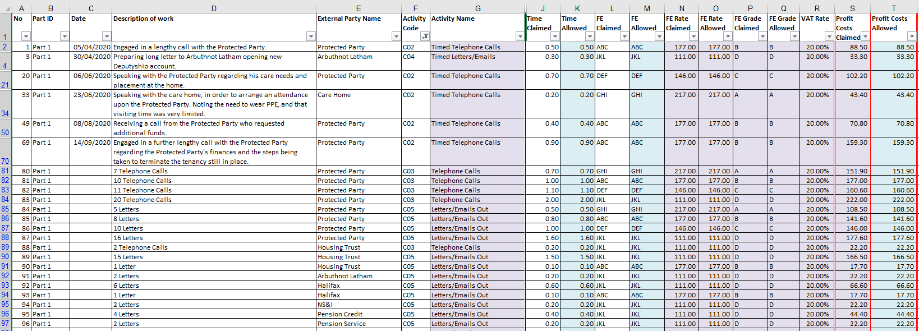

**Appendix F: Short Form COP-E Format**

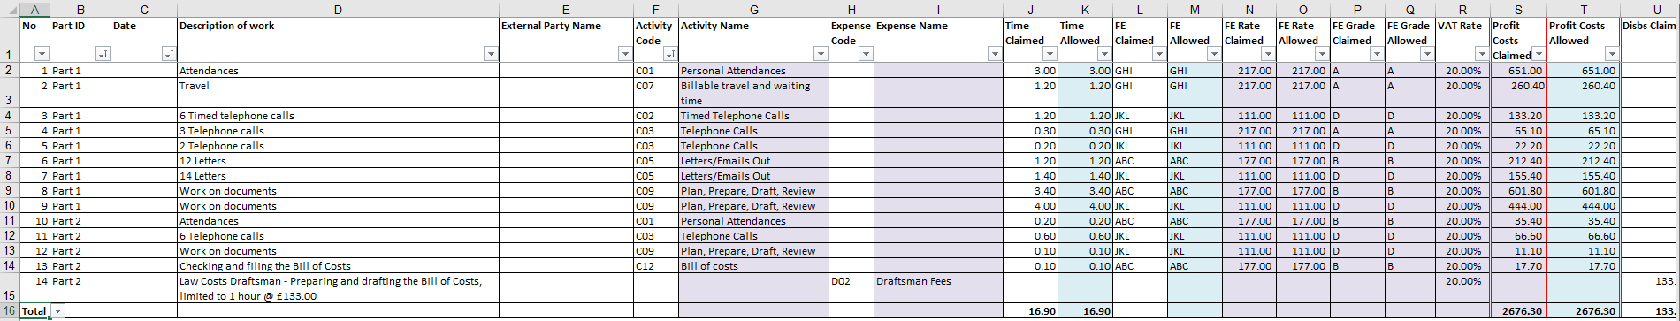

Magnified:

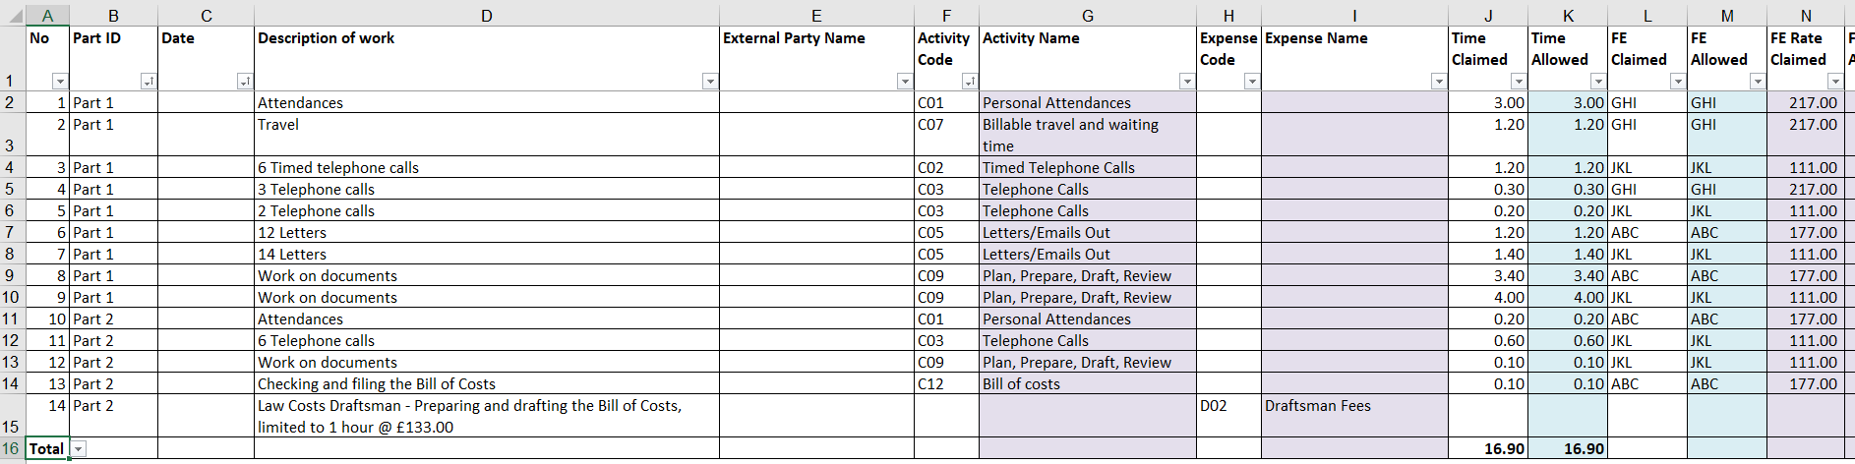

**Appendix G: Limiting COP-E Bill**

One Part Bill (for illustration purposes only):

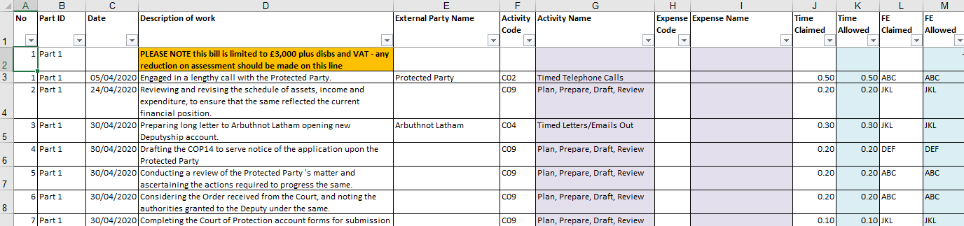

Multiple Part Bill (for illustration purposes only):

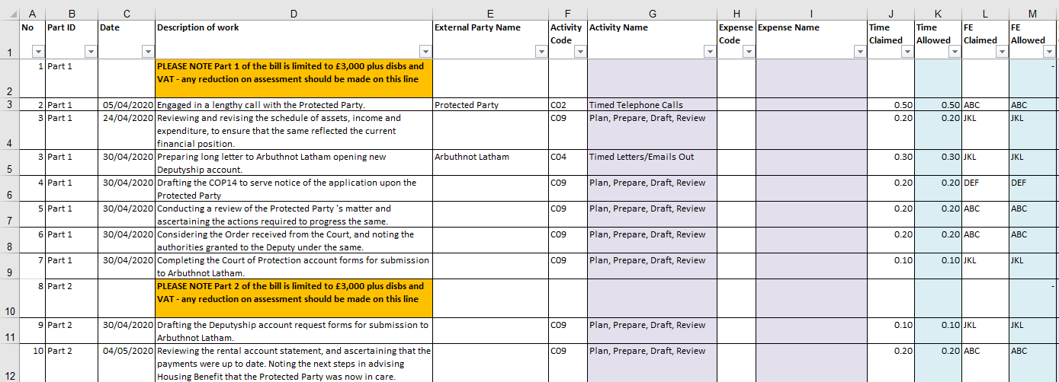

**Appendix H: Example Final Costs Certificate for General Management**

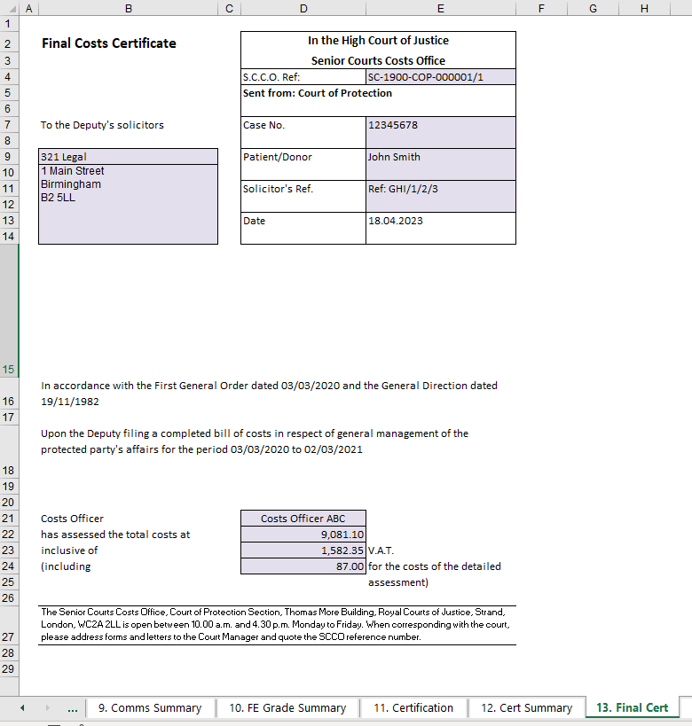

**Appendix I: Example Final Costs Certificate not for General Management**

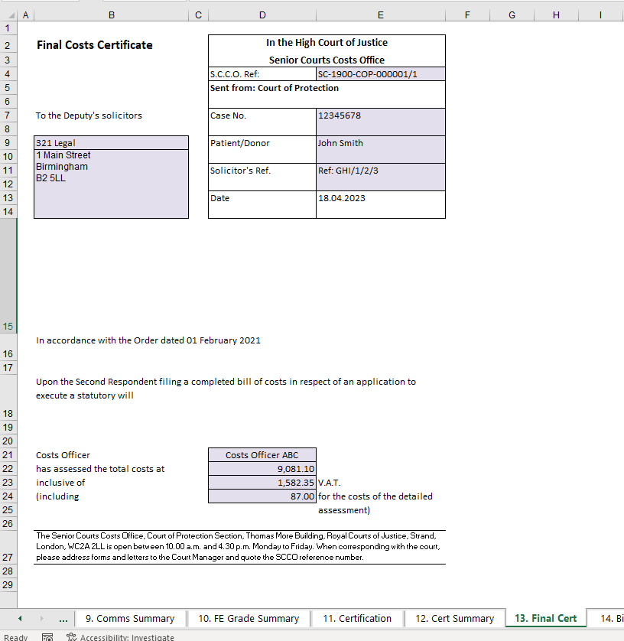

**Appendix J: Common Errors**

**COP-E Bill Pilot**

**COP E BILL COMMON ERRORS**

To help you to get your bill accepted in the first instance.

We have identified some common errors and misunderstandings that are being made when submitting the COP-E Bill

**Filing your COP-E Bill**

**CE File**

* COP-E Bills and requests for the final costs certificate must be filed under the new COP-E Bill filing options on CE File that begin with **COP-E**

**Versions**

* Please use the updated version of the COP-E Bill as it may be updated periodically. The up to date versions can be found at [Electronic bills in Court of Protection cases - Senior Courts Costs Office](https://www.judiciary.uk/guidance-and-resources/electronic-bills-in-court-of-protection-cases-pilot-in-the-senior-courts-costs-office/)

**Worksheet 1 – Front Sheet**

* Please ensure that all the required information is completed.
* If the patient is an ‘existing case’ (i.e. they are already on our system), please enter their SCCO reference in the space provided on Tab 1 in the format SC-[date]-COP-[6-digit number]. If the patient is not already on our system and is therefore a ‘new’ case, there will be no SCCO reference to enter.
* Please provide an email address for the bill to be returned to.
* If you have a valid DX address for supporting papers to be returned to, please include this.
* All information should be entered in the correct boxes. This ensures that the information feeds through to automatically populate other parts of the bill such as the final costs certificate.

**Worksheet 2 – Background**

* Wherever possible please complete the section requesting the value and breakdown of P’s assets. If they are not known please provide a reason rather than leaving the section blank.
* For General Management bills, the OPG105 information should always be entered, unless there is a valid reason for this. Again, please enter any reason rather than leaving the box blank, so that we are aware that this is not an accidental omission.

**Worksheet 4 – Fee Earners and Rates**

* The FE Grade column must be completed with the letter grade as per the guideline hourly rates, e.g. A, B, C, D. Please do not enter acronyms of titles here, or any other information that is not a grade.
* Please be aware that entering grades in other columns (e.g. FE Status) is not a substitute for filling out the FE Grade column itself.

**Worksheet 6 – Bill Detail**

* The Description of Work column must be completed for all entries
* Each entry must have either an activity code or an expense code
* All letters/emails (activity code CO5), telephone calls (CO3) and enclosure letters (CO6) must be entered collectively under each category and by fee earner rather than being listed individually. The Description of Work column must always state the number of letters/telephone calls/enclosure letters.
* Costs drafting fee - if the costs drafter is in-house then the amount claimed should be entered in the profit costs claimed column and Activity Code C12 should be applied. If the costs drafters are external the amount claimed should be entered in the disbursements claimed column and Expense Code D02 applied.

**Worksheet 11 – Certification**

* Only the pre-assessment section (i.e. the first ‘name’ and ‘firm’ boxes) should be completed when lodging the bill. The second set of boxes (marked as ‘post-assessment’ should only be completed once the bill has been assessed). Please do not delete the post-assessment section, as it will need to be completed to show acceptance of the amount allowed when the application for final costs certificate is made.
* Where it asks for ‘Name’ this must be the printed name of an individual authorised to sign on behalf of the firm (not the name of the firm).  This must not just be a copied signature unless you print their name next to it.

**Filing of Final Costs Certificate**

**Worksheet 11 – Certification**

* The post-assessment ‘name’ and ‘firm’ boxes should be completed to show that you accept the provisional assessment.

**Worksheet 13 – Final Cert**

* Please ensure you complete all 3 blank fields

1. The date of the final costs certificate (column E). *This is the date that you filled out the certificate.*
2. The details of the relevant authority (row 16 - In accordance with …..). Assuming that your authority is an order from the Court of Protection the first line should read ‘In accordance with the Order of the Court of Protection dated [*date of order*]’.
3. Details of the party filing the bill and the bill title (row 18)   
   “Upon *[enter party]* filing a completed bill of costs in respect of *[enter description of type of costs*])”   
    - For the party filing the bill, please ensure you enter either the role (e.g. deputy / applicant / respondent) of the person whose behalf the bill was filed, or alternatively, the name of the firm.

**Separate PDF Copy of the final costs certificate**

* In accordance with the guidance, when applying for your final costs certificate you should file with the SCCO a copy of the provisionally assessed COP-E BILL **and** a separate PDF copy of the final costs certificate for sealing. A separate copy of the certificate summary sheet is not required for a COP-E bill as it can be found on Tab 12 of the bill.
* The Final Costs Certificate for sealing must be a PDF of the completed Tab 13.  Please do not use the same certificate templates that you would use for a paper bill.  To produce a separate PDF, ensure that Tab 13 is open on your screen, then go to File – Export – Create PDF/XPS.  Save the PDF to your system and then upload as part of the filing.

**COP-E BILLS with supporting file(s) in paper format**

Where you intend to manually file physical supporting papers, upon acceptance of your COP-E Bill you will receive a message which includes the request to *‘enclose a copy of this acknowledgment notification with your papers endorsed with a return address of where your papers should be returned to (inc any DX address)’* In order that your papers are returned to your preferred destination as quickly as possible it would be helpful if you could fulfil this request.

If you have any queries, please feel free to contact us at SCCO@justice.gov.uk