Regulation 28: REPORT TO PREVENT FUTURE DEATHS

NOTE: This form is to be used after an inquest.
REGULATION 28 REPORT TO PREVENT DEATHS THIS REPORT IS BEING SENT TO:
- Health & Safety Executive
- Road Transport Industry Training Board
- COVEY TIMCOM The Timber Packaging and Pallet Confederation
- The Director - The Associate of Pallet Networks
1 | CORONER  I am Sarah WATSON, Assistant Coroner for the coroner area of North Yorkshire and York
2 | CORONER’S LEGAL POWERS  I make this report under paragraph 7, Schedule 5, of the Coroners and Justice Act 2009 and regulations 28 and 29 of the Coroners (Investigations) Regulations 2013.
3 | INVESTIGATION and INQUEST  On 23 September 2020 I commenced an investigation into the death of John Anthony IBBOTSON aged 57. The investigation concluded at the end of the inquest on 07 February 2023. The conclusion of the inquest was that:  Mr John Anthony Ibbotson was 57 years of age who, at the time of his death worked as a warehouse operative at Systagenix Wound Management Ltd, Airebank Mills, Gargrave, Skipton BD23 3RX.  He arrived at work at around 06:30 am on Monday 21st September 2020. Sometime thereafter his colleagues went looking for him as he had not been seen for a while.  He was found in the raw materials storage, bulk storage area (RMGJ05), this was an area in which he was authorised to work.  He was a trained warehouse operative with up-to-date forklift truck training. He was known to be safety conscious and not a risk taker.  Mr Ibbotson was found in a sitting position, leaning forward with a pallet on top of his back. The incident was reported to the police at 08:38. The paramedics pronounced lift extinct at 08:53.  On balance of probability, it is more likely than not that the pallets were double stacked and not in the pyramid/brick formation, but likely that one pallet was stacked directly on top of the other.  It is unclear what caused the pallet to fall.
4 | CIRCUMSTANCES OF THE DEATH
5 | CORONER’S CONCERNS  During the course of the investigation my inquiries revealed matters giving rise to concern. In my opinion there is a risk that future deaths could occur unless action is taken. In the circumstances it is my statutory duty to report to you.  The MATTERS OF CONCERN are as follows: (brief summary of matters of concern)

- There was a lack of awareness of the content of the relevant British Standards, European Standards and International Standards as they relate to the stacking of single deck pallets.
- The lack of information that is presently passed down the supply chain as to the supply and use of the ‘single deck’ pallets.

Awareness of British standards
BS EN ISO 445:2013 – Pallets for material handling. Vocabulary provides at 3.2 a description of a single deck flat pallet as one where the lower bearing surface s less than the percentage specified in ISO 6780.
BS ISO 6780:2003 Flat pallets for intercontinental materials handling. Principal dimensions and tolerances – states at 4.6 that the minimum bearing surface requirement for all pallets shall be 35% of the nominal bottom deck plan dimension (pallet footprint).
BS EN 13382:2002 Incorporating Corrigendum No1 Flat Pallets for material handling. Principal Dimensions specifically refers to stacking of single-deck pallets. At 4.6.2 it states: Single deck pallets shall not be stacked.

The Court received evidence that the standards are not freely available and instead a fee is payable to the British Standards Institute in order to access the safety information that the HSE includes in the reference section of Guidance Note PM15 (Fourth Edition). The standards are not legally binding but they are relied upon by the HSE as evidence of best practice.

The HSE should consider increasing awareness of the content of the relevant standards. The HSE should consider updating PM15 to include specific reference to the parts of the relevant standards which contain the safety related information. In particular, the parts that define a single-deck pallet and the suggested prohibition on stacking.

Training
The Road Transport Industry Training Board should consider including the prohibition on stacking single deck pallets as part of the curriculum.

Single deck pallets
Pallets are not currently labelled to indicate whether they should be stacked as a single- deck pallet.

TIMCOM/The Association of Pallet Networks should consider introducing a standardised system to enable easy identification of single deck pallets.
6 | ACTION SHOULD BE TAKEN  In my opinion action should be taken to prevent future deaths and I believe you (and/or your organisation) have the power to take such action.
7 | YOUR RESPONSE  You are under a duty to respond to this report within 56 days of the date of this report, namely by May 10, 2023. I, the coroner, may extend the period.  Your response must contain details of action taken or proposed to be taken, setting out the timetable for action. Otherwise you must explain why no action is proposed.
8 | COPIES and PUBLICATION  I have sent a copy of my report to the Chief Coroner and to the following Interested Persons

I have also sent it to

British Standards Institute

who may find it useful or of interest.

I am also under a duty to send a copy of your response to the Chief Coroner and all interested persons who in my opinion should receive it.

I may also send a copy of your response to any person who I believe may find it useful or of interest.

The Chief Coroner may publish either or both in a complete or redacted or summary form. He may send a copy of this report to any person who he believes may find it useful or of interest.

You may make representations to me, the coroner, at the time of your response about the release or the publication of your response by the Chief Coroner.
9 | Dated: 16/03/2023  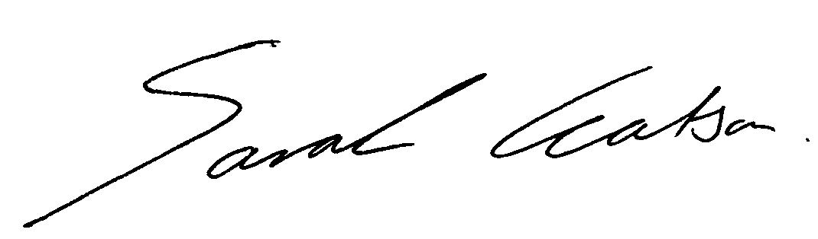  Sarah WATSON Assistant Coroner for  North Yorkshire and York

